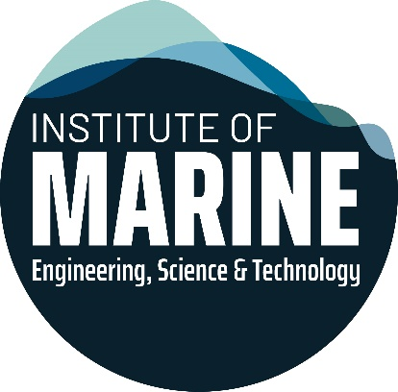
IMarEST CPD Recognition Application Questions
- The aims/philosophy of the course
- What are the overall educational or developmental aims of the course?
You may upload a document in answer to this question if you wish
- Objectives of the course
- What objectives should participants be able to meet on completing the course?
- What should attendees know or be able to do on completion?
You may upload a document in answer to this question if you wish
- Brief overview of the course syllabus
- What topics will be covered in the course?
- How are learning outcomes delivered?
- How long does the training take to complete?

- Projected learning outcomes of the course
- Are learning outcomes assessed and what are the methods of assessment?
- Are participants required to pass any assessment to complete the course?

- What level of learning does the course provide?
- Is the training course introductory? Aimed at proficiency with a specific product?
- High level technical assessment?

- Target audience for the course
- Is the course aimed at a particular audience?
You may upload a document in answer to this question if you wish
- Training instructor CVs
- Please upload CVs for all the training instructors delivering this course.
This should outline the training instructor's experience and expertise in relation to the topics they are delivering training for, as well as describing how they maintain their professional competence.
- Resources required
- What resources are required to deliver the course?
- Is the course delivered in person or through online learning?
Please provide course materials and plans if possible

- Feedback
- Please provide a record of previous attendees (if possible) and examples of feedback evaluation and continuous improvement.
- How is feedback assessed and how are recommendations considered and implemented?

- Quality assurance processes
- How is the quality of the course ensured?
- How is the course material assessed to ensure relevance?

